|  |
| --- |
| DYNAMIC LINK |
| SITE MANUAL |
| The full guide to the Dynamic Link | Libraries website |

|  |
| --- |
| Carl Ivan  [Date] |

Table of Contents

SITE ACCESS 2

USER-ORIENTED PAGES 4

USER-ORIENTED PAGES 5

HOME PAGE 5

SEARCH PAGE 6

MY RENTALS PAGE 7

ADMINISTRATIVE PAGES 8

HOME PAGE 9

DATA MANIPULATION 10

BOOKS 10

AUTHORS 11

PUBLISHERS 12

CALL NUMBERS 13

USER ACCOUNTS 13

BORROWERS 14

RENTALS 15

# SITE ACCESS

There are two important pages that the user would first need to explore before being able to use the site to its full potential.

FIG.1 SIGN UP SCREEN

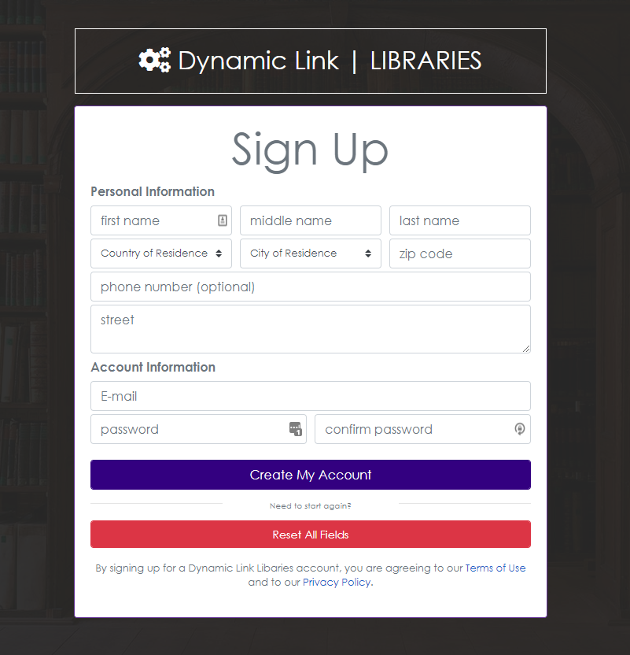

The sign-up page is where an individual would sign up. Signing up would grant renting privileges to the user.

The login page on the other hand will allow any user with valid credentials to access all the user-oriented features of the site.

FIG.2 LOG IN SCREEN

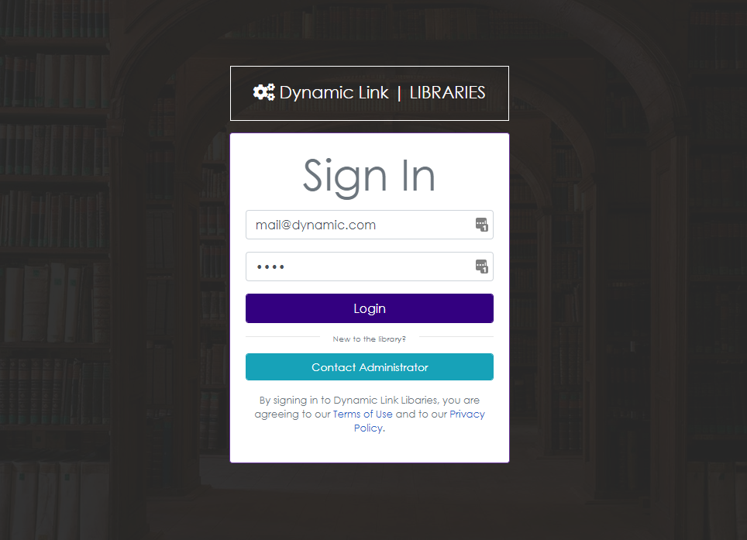

|  |
| --- |
| USER-ORIENTED PAGES |

**xcecec**

# USER-ORIENTED PAGES

The site has a separate component for administrative pages. This section will focus on user-oriented pages. Meaning anything discussed here will be especially important in the overall user experience.

## HOME PAGE

FIG.3 HOME SCREEN

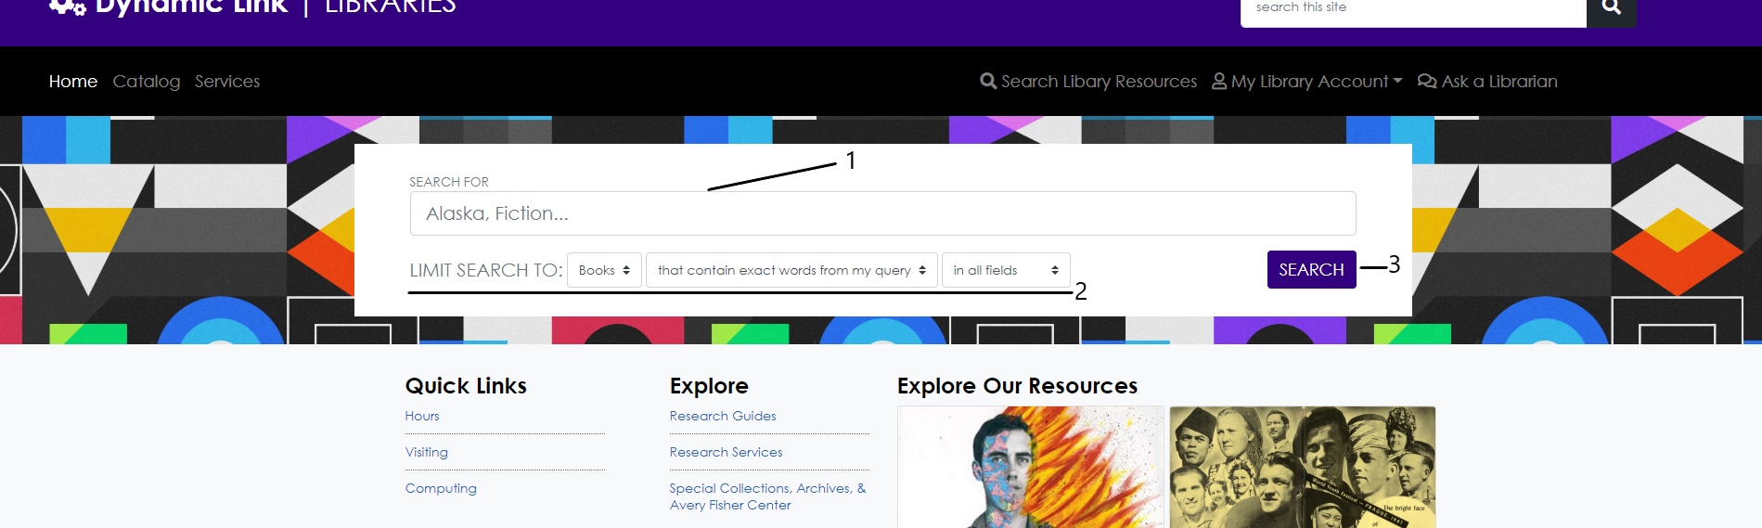

The home page incorporates a search box which would allow the user to easily find the exact book he wants to look at or rent out.

1. The control identified by **1** is where users will enter their search terms. These terms will be used when looking for titles that are like that of the given search terms.
2. The control set identified by **2** will allow the user to narrow down the search. The default settings will bring up titles that match the given search terms in all available aspects such as title, author, publisher, call number etc.
3. The control identified by **3** will commence the search. This can also be done by pressing the *enter* or *return* key.

## SEARCH PAGE

FIG.4 SEARCH SCREEN

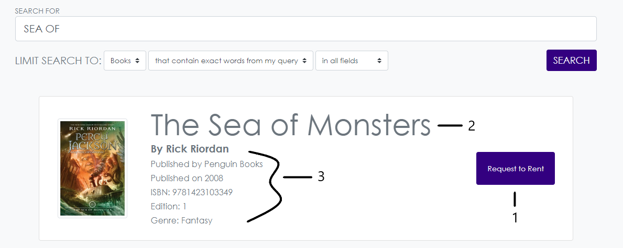

The search page would show all relevant results found by using the specified search options. In this page, the user can ask the administrator if he could rent a book.

1. By pressing the control identified by **1**, the user would be prompted if he would like to proceed with requesting for a rental of the book.

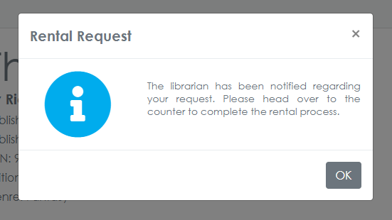

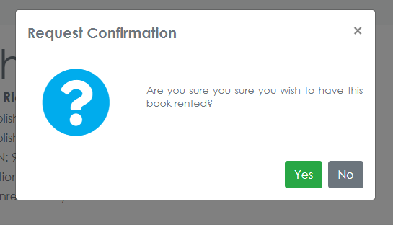

FIG.4A RENTAL CONFIRMATION DIALOGS

By confirming the rental, the request will be sent to the administrator and the user will be notified of this as well. Although, the user must proceed to the administrator personally to complete this process.

1. The part identified by **2** indicates the *author* of the book.
2. The part identified by **3** indicates specific details about the book such as its publisher, year of publication, edition, ISBN and genre.
3. For each book present in the database, a card containing details about is presented to the user when necessary. Close to it is a button that would allow the user to send a rental request to the administrator. This button also indicates the book’s status in library.

FIG.4B BUTTON STATUSES

|  |  |  |  |
| --- | --- | --- | --- |
|  |  |  |  |

## MY RENTALS PAGE

The site also comes with a page that would allow the user to check or view all the books he is currently renting. This would display information about the rental such as the start and end date of the rental and details about the rented book.

FIG.5 MY RENTALS PAGE

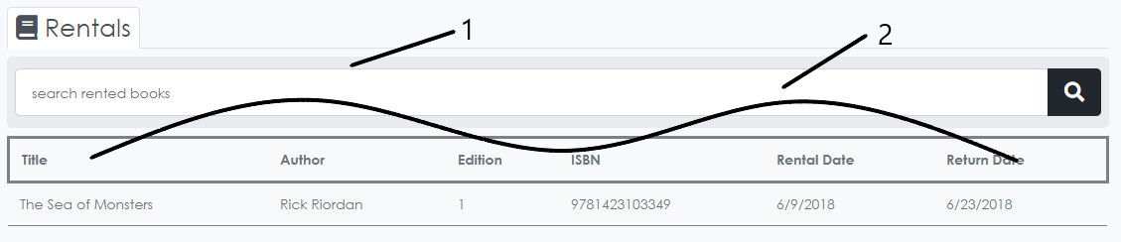

1. The control identified by **1** would allow the user to search a rented book. This would search in all available aspects such as: title, author, edition and ISBN.
2. The items encompassed and identified by **2** are the details associated with each rental.

|  |
| --- |
| ADMINISTRATIVE PAGES |

**xcecec**

## HOME PAGE

FIG.6 ADMINISTRATION HOME

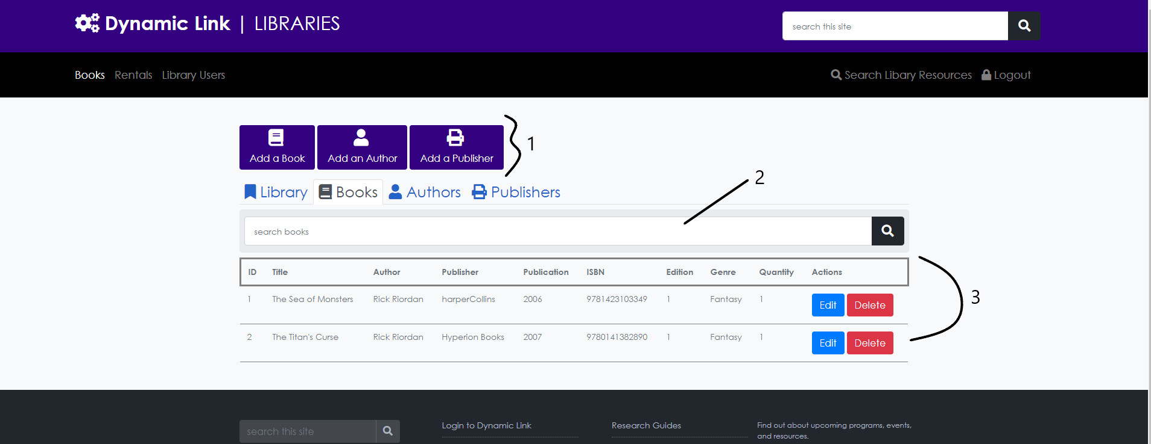

The page has a control set as identified by **1**. This control set would allow the administrator to add new information to the database.

* The **Add Book** button would allow the administrator to add a new book to the database.
* The **Add an Author** button would allow the administrator to add a new author to the database.
* The **Add a Publisher** button would allow the administrator to add a new publisher to the database.

The home page for the administration component of the site is quite straightforward. There are four tabs that would allow the administrator to view and manage all data in their corresponding categories.

* The **Library tab** allows the administrator to manage library indexing for the books available in the library.
* The **Books tab** allows the administrator to manage information associated with each book in the library.
* The **Authors tab** allows the administrator to manage information associated with each author in the database.
* The **Publishers tab** allows the administrator to manage information associated with each publisher in the database.

Each tab in this page follows the same layout. Every tab will have all the same sections and components.

1. The control set identified by **2** will allow the administrator to search the grid or table that is currently shown.
2. The grid or table is identified by **3**. This would show all necessary information from the database.
3. In the table identified by **3**, there are two buttons. These buttons will allow the user to modify or delete the row of data.

## DATA MANIPULATION

Each data present or added in the database can be modified. This section will explain how this is done. This section is arranged as follows: Books and related information followed by User related tables then Rental details.

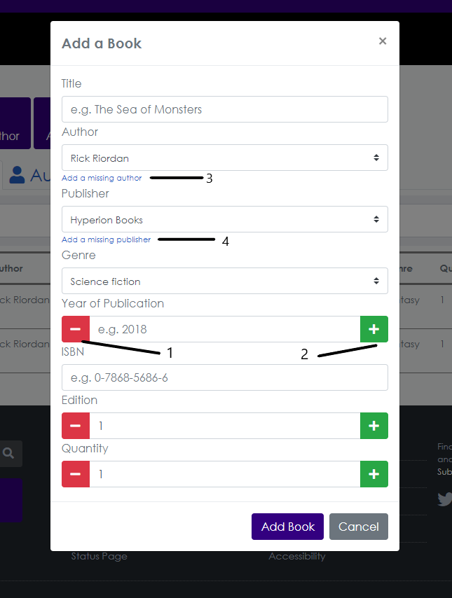

### BOOKS

1. This card would allow you to add a **new book** to the database. All the fields are required and are also labeled accordingly. The controls identified by **1** and **2** will allow you to increase or decrease the value in the textbox by one. There are also shortcuts to adding a new author or a publisher as identified by **3** and **4** if the need for them arises.
2. By clicking on the *edit* button found in the table in the **books tab**, you will be able to edit or update the information associated with a specific book. Make sure to click on the purple update button once you are done to save your changes.

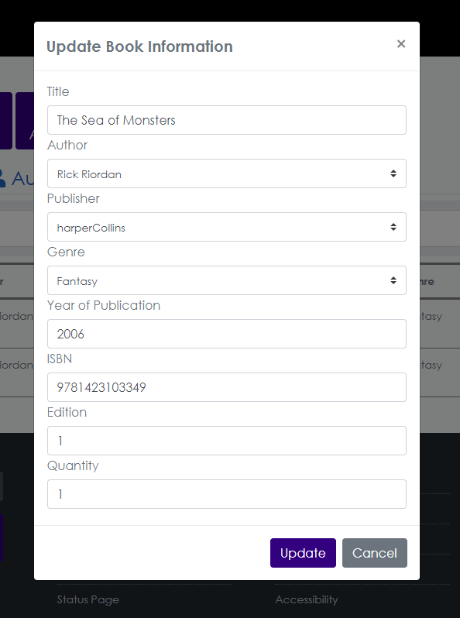

1. By clicking on the *delete* button in the table in the **books tab**, you will be asked if you are sure that you want to delete the book’s information from the database. Confirming this action will remove all associated information and is automatically reflected in the database.

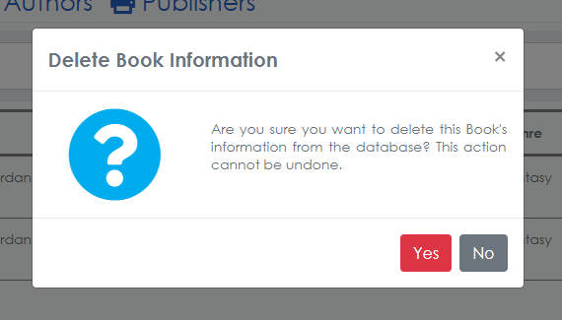

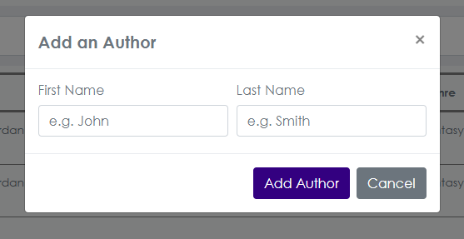

### AUTHORS

1. By clicking on the *Add an Author* button in the control set above the tabs, you will be able to add a new author to the database. Each field must be filled in to complete this process.

1. By clicking the *edit* button found in the table available in the **Authors tab**, you will be able to edit the information associated with an author in the database.
2. By clicking on the *delete* button in the table in the **Authors tab**, you will be asked if you are sure that you want to delete that author’s information from the database. Confirming this action will remove all associated information (like books written) and is automatically reflected in the database.

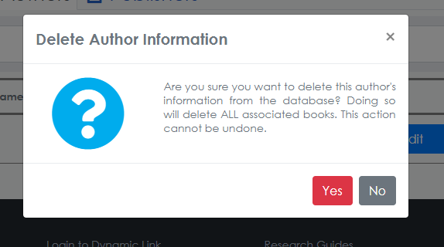

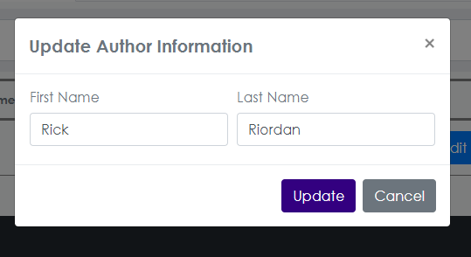

1. By clicking on the *delete* button in the table in the **Publishers tab**, you will be asked if you are sure that you want to delete that publisher’s information from the database. Confirming this action will remove all associated information (like books published) and is automatically reflected in the database upon confirmation.
2. By clicking the *edit* button found in the table available in the **Publishers tab**, you will be able to edit the information associated with a publisher in the database.

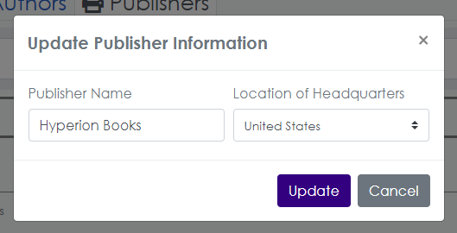

### PUBLISHERS

1. By clicking on the *Add a Publisher* button in the control set above the tabs, you will be able to add a new publisher to the database. Each field must be filled in to complete this process.

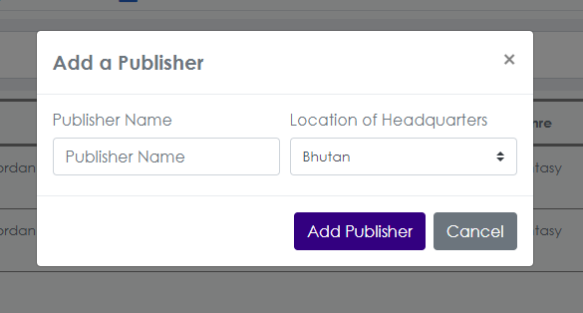

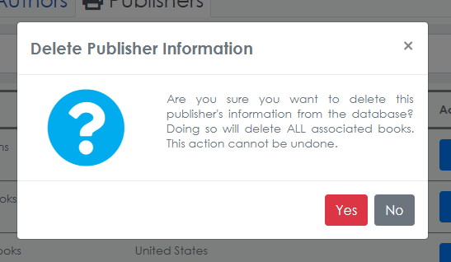

### CALL NUMBERS

1. By clicking on the *update* button in the table found in the **Library tab**, you will be able to assign a call number to the book.

*Every time a book is added, it does not have a call number assigned. You must assign this value yourself.

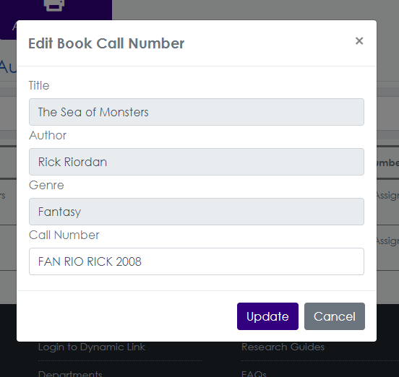

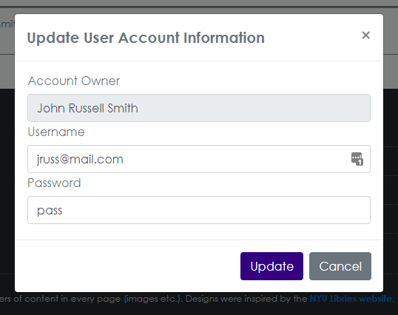

1. By clicking on the *delete* button in the table in the **Accounts tab** in the **Library Users** section of the administration component, you will be asked if you are sure that you want to delete that user’s account information from the database. Confirming this action will remove all associated information (like books rented and contact information) and is automatically reflected in the database upon confirmation.

*An account that is associated with a borrower that is currently renting a book cannot be deleted.

### USER ACCOUNTS

1. As each user must have his own account to borrow a book from the library, the system also comes with the utilities to manage these. Clicking on the *edit* button in the table available in the **Accounts tab** in the **Library Users** section of the administration component, you will be able to edit all information associated with a specific user’s library account.

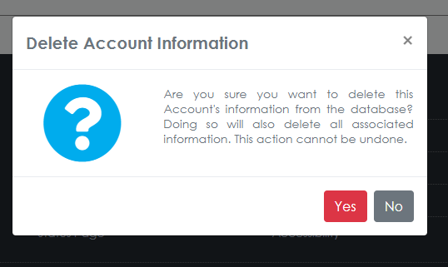

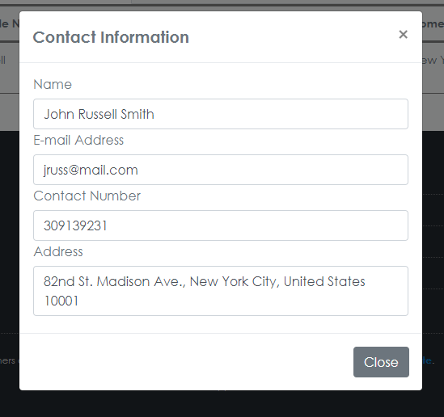

### BORROWERS

1. Given the registration requirement of this page, each user must provide a few personal details. These details are associated with each account in the database. By clicking on the *edit* button in the **Borrower Details** **tab**, you will be able to update any user provided information such as the name, e-mail address, home address and phone number of the borrower.

* The user can choose whether to or not to provide a phone number. If they do not and change their mind this piece of information can be updated here.

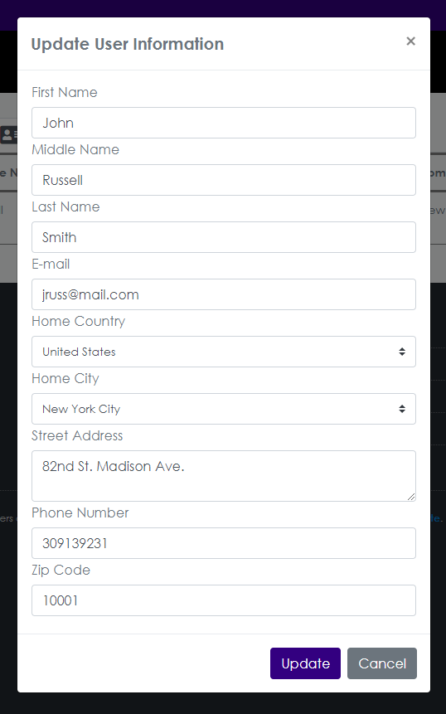

1. Only basic information is displayed in the table shown in the **borrower details tab**. Other details such as the contact number and home address can be viewed by clicking on the *view* button found under the **contact details** column for each user in the table.

### RENTALS

1. The *return date* for each ongoing book rental can be extended by clicking on the *extend* button available in the table present in the **Rentals tab**.

.

1. In case it was decided that the request will not be accepted, the rental request information will be deleted from the database. Once confirmed and completed, all information associated with the request can no longer be retrieved.

.

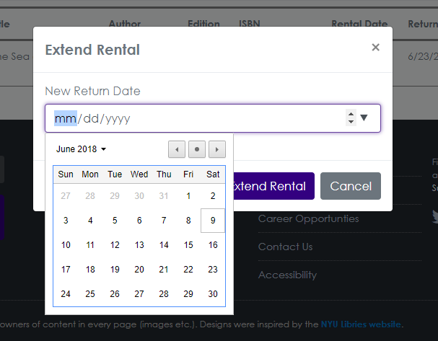

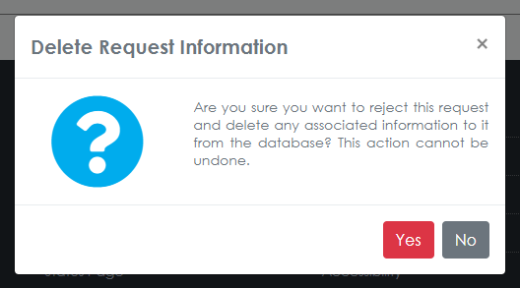

C:\Users\Carl Ivan\Desktop\Project Resources\res-DL-Libraries\Screen Captures\Admin\28 - REJECT REQUEST BUTTON.PNG

C:\Users\Carl Ivan\Desktop\Project Resources\res-DL-Libraries\Screen Captures\Admin\27 - ACCEPT RENTAL BUTTON.PNG

### RENTAL REQUESTS

1. Each borrower must first send a request to the administrator before he can have a book rented. In the **Rentals** section of the administration component, the administrator can decide whether to accept a rental request by clicking on the or b buttons.

* An accepted rental is automatically reflected in the user’s account.

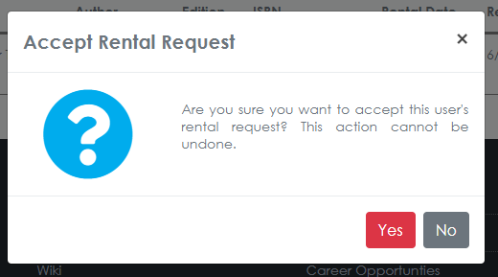



1. Like every other table in the administration component, by clicking on the *delete* button in the current table, you will be able to delete the selected information from the table. Confirming this action will remove all related information (like the user’s account and all associated rental information) from the database.

* Users who are currently renting a book from the library cannot have any associated information deleted.